Introductory to Operating Systems
COP 4600-002
Name and ID __Sean Dunford________

Homework #3

Due date: 11 /7/2012
Instructions:
HW must be submitted on typed pdf or word document.
You must do your work on your own. Late work will be not accepted.

Q1. Consider a paging system with main memory access time of 20 nanoseconds (this includes the effect of the page table hit ratio). Assume that it takes 650 microseconds to bring a page from disk to main memory when no frame replacement is needed. When page replacement is needed it takes 850 microseconds if the frame has not been modified and 1.5 milliseconds if the frame has been modified. Assume that on the average the system experience a page hit 99.995% of the time it addresses memory and that 25% of the time a page fault occurs the frame needs to be replaced. When a frame needs to be replaced, 15% of the time the frame has been modified.
Calculate the effective memory access time for this system under these conditions. Clearly indicate intermediate steps.
P = 99.995% = .99995
(1-P) = 0.005% = .00005

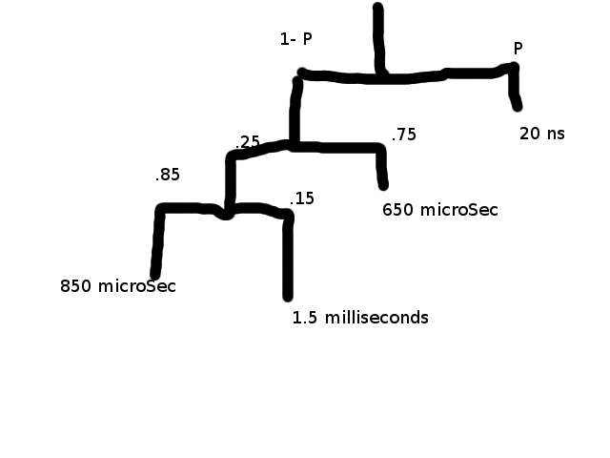

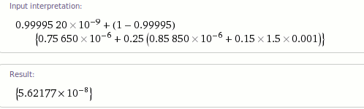

Q2. Consider the following page reference string:
1,2,3,4,2,1,5,6,2,1,2,3,7,6,3,2,1,2,3,6
How many page faults would occur for the following replacement algorithms, assuming three and four frames? The frames are initially empty, so your first unique pages will cost one fault each.
- LRU
- Optimal
- FIFO

Q3. What is the copy-on –write feature, and under what circumferences is it beneficial to use this feature?

Q4. What is a page fault interrupt?

Q5. One of the necessary conditions for deadlock is “hold and wait”. What resource allocation policy could an operating system implement to eliminate this condition?

Q6. Explain what is meant by the working set of a process?

Q7. Explain the relationship between a “working set” and “thrashing”.

